PROJECT REPORT
Implement Client Script and UI Policy [Incident]
ServiceNow Incident Form: dynamic field control using Client Scripts and UI Policies
Detail | Information
Team ID | SWTID-2026-2511
Team Size | 5
Team Leader | Ritika L
Team Members | Monisha A  Saranya G  Roshini A V  Yashika K
Date | 04 October 2026

1. INTRODUCTION

1.1 Project Overview
This project implements Client Scripts and UI Policies on the ServiceNow Incident form to improve user experience, enforce field behavior and reduce incorrect data entry. The form reacts to user actions and incident conditions dynamically, without requiring the form to be submitted.
A UI Policy is created on the Incident table to control selected fields based on defined conditions. When a condition is met, fields can be made mandatory, read-only or visible, so users provide the required information and follow consistent data-entry practices while creating or updating Incident records. Client Scripts add further checks and instant messages on the form.

1.2 Purpose
The purpose of the project is to:
- make sure the right information is captured on every incident;
- guide users by showing, hiding or locking fields according to the incident state;
- reduce errors and incomplete records caused by manual data entry; and
- give users immediate feedback on the form instead of after submission.

2. IDEATION PHASE

2.1 Problem Statement
Incident forms contain many fields, and users often leave required details empty, enter inconsistent values or edit fields that should be locked at a given stage. This leads to incomplete incident records, extra follow-up work and lower data quality. Errors are usually noticed only after the form is submitted.
Problem statement element | Description
I am | A service desk agent or an incident caller
I am trying to | Create and update incident records correctly and quickly
But | Required fields are missed and some fields are edited at the wrong stage
Because | The form does not adapt to the incident condition or warn the user in time
Which makes me feel | Frustrated and unsure what the form expects from me

2.2 Empathy Map Canvas
Empathy map for the main user, a service desk agent working on incidents:
Quadrant | Observations
Says | "Which fields do I have to fill in?"  "Why was my update rejected?"
Thinks | I want to close this incident quickly without mistakes.  I am not sure what is required for this state.
Does | Fills in the form, saves, and corrects errors afterwards.  Sometimes skips details to save time.
Feels | Frustrated by rework, worried about incomplete records, and relieved when the form guides them.
Pains | Unclear required fields, errors found late, inconsistent data entry.
Gains | Clear guidance on the form, fewer corrections, consistent and reliable records.

2.3 Brainstorming
The team considered the following ideas and chose the ones that directly address the problem:
Idea | Selected? | Reason
UI Policy to make fields mandatory based on State | Yes | Enforces required data at the right time
UI Policy to make fields read-only / visible | Yes | Keeps the form clean and prevents wrong edits
Client Script onChange messages | Yes | Immediate feedback without saving
Client Script onSubmit validation | Yes | Stops invalid submissions
Business Rule for server-side enforcement | Later | Useful, but outside current scope
Custom form layout for each role | Later | Needs extra roles and design work

3. REQUIREMENT ANALYSIS

3.1 Customer Journey Map
Stage | User action | User feeling | Pain point | How the solution helps
Create | Opens a new Incident | Neutral | Many fields, unclear which matter | Relevant fields shown; guidance on the form
Update | Changes the State | Hopeful | Unsure what is now required | UI Policy makes the needed fields mandatory
On Hold | Puts incident On Hold | Rushed | Forgets the reason | On hold reason becomes mandatory
Resolve | Resolves the incident | Wants to finish | Missing close details | Close code and Close notes become mandatory
Close | Reviews the closed record | Relieved | Closed data edited by mistake | Selected fields become read-only

3.2 Solution Requirements
Functional requirements
ID | Requirement
FR-1 | Make selected Incident fields mandatory when the defined condition is met.
FR-2 | Make selected fields read-only when the defined condition is met.
FR-3 | Show or hide selected fields based on field values.
FR-4 | Restore the default field behavior when the condition is no longer true (Reverse if false).
FR-5 | Show instant messages for missing or incorrect entries using Client Scripts.
FR-6 | Behave the same way when creating a new incident and updating an existing one.

Non-functional requirements
ID | Requirement
NFR-1 | Usability: users get feedback on the form without submitting it.
NFR-2 | Performance: field changes happen instantly in the browser.
NFR-3 | Maintainability: rules are configured as UI Policy and Client Script records that can be edited by an administrator.
NFR-4 | Consistency: the same rules apply to every user who opens the form.

3.3 Data Flow Diagram
The user enters data in the Incident form. The form passes field values and events to the UI Policy and Client Script, which respond by changing field behavior and showing messages. When the user saves, a valid record is stored in the Incident table.
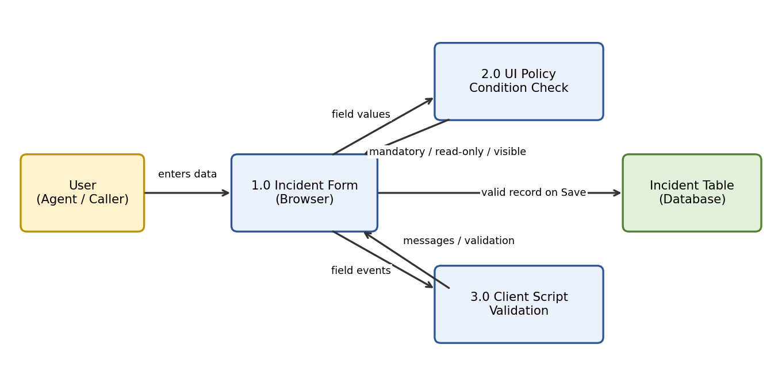
Figure 1: Data flow diagram

3.4 Technology Stack
Component | Technology
Platform | ServiceNow (Personal Developer Instance)
Table | Incident (incident)
Form rules | UI Policy and UI Policy Actions
Scripting | Client Scripts (JavaScript): onLoad, onChange, onSubmit
Client API | g_form (getValue, setMandatory, setReadOnly, setDisplay, showFieldMsg)
Deployment | Update Set
Access | Web browser

4. PROJECT DESIGN

4.1 Problem Solution Fit
Problem | Solution fit
Required details are missed | UI Policy makes fields mandatory when the condition applies
Fields edited at the wrong stage | UI Policy makes fields read-only
Cluttered form | Fields are shown only when relevant
Errors noticed after submission | Client Scripts show messages and validate before submit

4.2 Proposed Solution
Create a UI Policy on the Incident table with conditions on fields such as State and Category. Each UI Policy action sets a field to mandatory, read-only or visible. Enable "Reverse if false" so the form returns to normal when the condition no longer applies. Add Client Scripts for checks that need a script, such as showing a message when a value is changed or blocking an invalid submit.
Item | Details
Condition: State is On Hold | On hold reason: Mandatory
Condition: State is Resolved / Closed | Close code and Close notes: Mandatory; selected fields: Read-only
Condition: Category is not empty | Subcategory: Visible
Client Script (onChange) | Message shown instantly when the monitored field changes
Client Script (onSubmit) | Invalid or incomplete data is stopped before saving
[Update the conditions and fields above to match the final implementation.]

4.3 Solution Architecture
The solution runs mainly on the client side in the browser. The Incident form uses the UI Policy and Client Scripts through the g_form API, and the ServiceNow platform stores the record in the Incident table and manages users, roles and access controls.
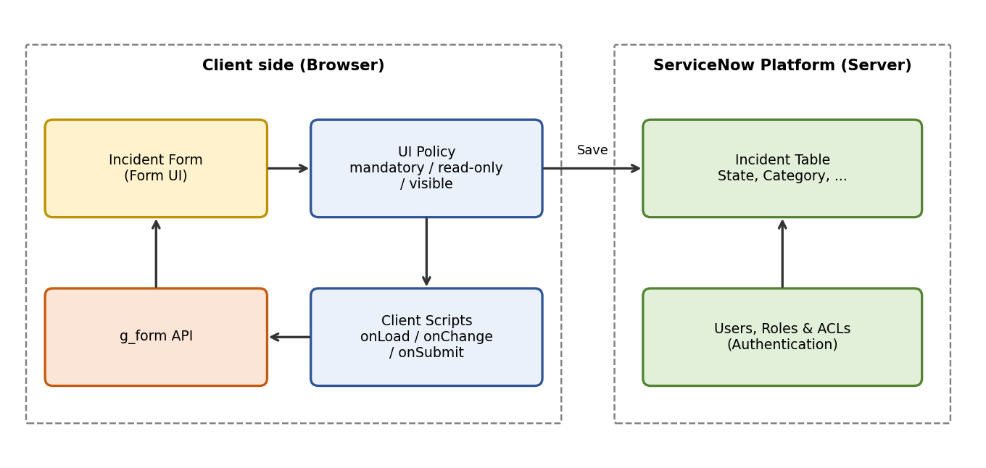
Figure 2: Solution architecture

5. PROJECT PLANNING & SCHEDULING

5.1 Project Planning
Phase | Activities | Owner | Status
Ideation | Problem statement, empathy map, brainstorming | [Assign] | [Status]
Requirement analysis | Journey map, requirements, data flow, tech stack | [Assign] | [Status]
Environment setup | Request ServiceNow PDI, review Incident form | [Assign] | [Status]
Development | Create UI Policy and Client Scripts | [Assign] | [Status]
Testing | Functional testing and UAT (10 test cases) | [Assign] | [Status]
Documentation | Project documentation and final report | [Assign] | [Status]
[Add start and end dates and assign team members.]

6. FUNCTIONAL AND PERFORMANCE TESTING

6.1 Performance Testing
The solution was tested manually on the Incident form, for both new and existing incidents. Ten User Acceptance Testing cases (TC-001 to TC-010) cover positive and negative scenarios.
Area | Scenarios tested | Total cases | Passed
UI Policy | Mandatory, read-only and visible behavior; reverse if false | 7 | 7
Client Script | onChange message; onSubmit validation | 2 | 2
Form behavior | New and existing incident | 1 | 1
Total |  | 10 | 10
[Enter the pass counts and screenshots from the UAT document.]

7. RESULTS

7.1 Output Screenshots
[Insert screenshot: On hold reason mandatory when State is On Hold]
[Insert screenshot: Close code and Close notes mandatory when State is Resolved]
[Insert screenshot: Read-only and hidden fields on the Incident form]
[Insert screenshot: Client Script message shown on the form]
[Insert screenshot: UI Policy and Client Script configuration]

8. ADVANTAGES & DISADVANTAGES
Advantages
- Users see only the relevant fields and know what is required.
- Fewer incomplete and inconsistent incident records.
- Instant feedback on the form, without submitting it.
- Easy to configure and change by an administrator.
Disadvantages
- UI Policies and Client Scripts run only in the browser, so records created through imports or APIs are not checked.
- Many rules or scripts can make the form harder to maintain.
- Server-side rules are still needed for strict data enforcement.

9. CONCLUSION
The project shows how UI Policies and Client Scripts can make the ServiceNow Incident form guide users, enforce field behavior and reduce incorrect data entry, all without submitting the form. The result is a more consistent and user-friendly data-entry process for creating and updating incidents.

10. FUTURE SCOPE
- Add Data Policies or Business Rules to enforce the same rules on the server side.
- Apply similar behavior to other tables and to Service Catalog items.
- Add role-based conditions so the form differs by user group.
- Package the changes as a scoped application for easier deployment.

11. APPENDIX
Source Code
Example onChange Client Script (replace with the team's final script):
function onChange(control, oldValue, newValue, isLoading, isTemplate) {
if (isLoading || newValue === '') { return; }
if (newValue == '3') { // State = On Hold
g_form.setMandatory('hold_reason', true);
g_form.showFieldMsg('hold_reason', 'Please enter the reason for putting this incident on hold.', 'info');
} else {
g_form.setMandatory('hold_reason', false);
}
}

Dataset Link: Not applicable. The project uses the standard Incident table of the ServiceNow instance.
GitHub & Project Demo Link: [Add link]

